Time Series Analysis and Forecasting of Daily Oil Prices (2024–2026)

Github: https://github.com/ansmalik67/time_series_analysis.git

Introduction
Oil price forecasting is an important task because oil affects transport costs, inflation, production costs, and the wider economy. However, oil prices are difficult to predict because they change due to many connected factors, such as supply decisions, market expectations, global demand, and political events. Recent research also shows that oil prices often contain nonlinearity, volatility shifts, and structural changes, which means that one simple model is rarely perfect for every period.
This report analyses daily oil prices from 2024 to 2026 using three forecasting approaches: ARIMA, Prophet, and LSTM. ARIMA was the main model because it required full testing for non-stationarity and a complete search across the different parameter ranges. Prophet and LSTM were added to compare the classical statistical approach with a modern trend-based model and a deep learning sequence model. ARIMA in statsmodels supports likelihood-based model comparison using AIC and forecast intervals, Prophet provides built-in trend and uncertainty modelling, and Keras provides maintained tools for sequence-based LSTM forecasting.
The aim of the analysis was not only to build a forecast, but also to explain the behaviour of the oil price series, justify modelling choices, compare results critically, and examine how forecasts matched the real values that appeared after the training period.

Data Description and Initial Exploration
The dataset contained 500 daily observations of oil prices. After cleaning and preprocessing, the date column was converted into a daily time index and the price variable was used as the main series. Summary statistics:
- Count: 500
- Mean: 75.87
- Standard deviation: 42.91
- Minimum: 16.48
- 25th percentile: 35.37
- Median: 64.29
- 75th percentile: 111.57
- Maximum: 158.78
These values already show that the dataset has a wide spread. The difference between the minimum and maximum is very large, which suggests that oil prices changed strongly over the observed period. The standard deviation is also high, so the series does not stay close to a single average level.
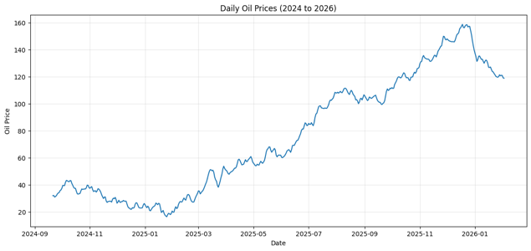Figure 1: Daily oil price series, 2024–2026
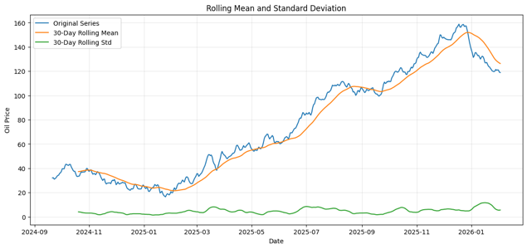Figure 2: Rolling mean and rolling standard deviation
Rolling Statistics and Why They Matter
Also calculated a 30-day rolling mean and 30-day rolling standard deviation. This is a useful step because it helps check whether the average level and variability stay stable through time.
If a time series is stationary, its mean and variance should stay relatively stable. In this analysis, the rolling mean changed over the sample, which showed that the average oil price level was moving rather than staying fixed. The rolling standard deviation also changed, which suggested that the variability was not perfectly constant.
Rolling statistics do not prove stationarity by themselves, but they provide strong visual evidence. Their role in this is to build the narrative that firstly, the raw series looks unstable, then the rolling statistics confirms that instability, and after that the formal tests explains it numerically.
Stationarity Testing
Stationarity is one of the most important ideas in ARIMA modelling. A stationary series has a more stable mean structure, which makes autoregressive and moving-average effects easier to estimate. To test stationarity properly, the colab file used both the Augmented Dickey–Fuller (ADF) test and the KPSS test. This is a strong choice because the two tests look at stationarity from opposite sides ADF tests for a unit root, while KPSS tests for stationarity. Using both reduces the chance of drawing a weak conclusion from only one test.
For the original oil price series, the results were:
- ADF statistic: -0.5462
- ADF p-value: 0.8827
- KPSS statistic: 3.7056
- KPSS p-value: 0.0100
The ADF result failed to reject the null hypothesis of a unit root, while the KPSS result rejected the null of stationarity. Both tests therefore pointed in the same direction the original series was non-stationary.
It means that the raw oil prices were not suitable for a plain stationary ARMA-type interpretation. If this step had been skipped, later model results would have been less trustworthy. The formal tests justified the next stage of the modelling process rather than making differencing a random choice.
Differencing and Making the Series Stationary
After confirming that the original series was non-stationary, the colab file tested both first and second differencing.
For the first-differenced series, the results were:
- ADF statistic: -4.5415
- ADF p-value: 0.000165
- KPSS statistic: 0.1903
- KPSS p-value: 0.1000
For the second-differenced series, the results were:
- ADF statistic: -3.9076
- ADF p-value: 0.001979
- KPSS statistic: 0.1935
- KPSS p-value: 0.1000
Both differenced series appeared stationary by these tests. However, this does not mean that the second difference is automatically better. A main point here is that more differencing is not always better. Too little differencing leaves trend in the data, but too much differencing can remove useful structure and make the series more noisy than necessary.
From a modelling point of view, the first difference was already enough to make the series stationary. That means the data did not need a stronger transformation just for the sake of it. Still, because it required testing $d=0,1,2$, it was correct to keep all three values in the ARIMA search.
The report should not say only, “both were stationary.” It should explain that the first difference already solved the main problem, while the second difference was included because it was part of the full parameter search and because the model selection stage would decide whether the extra differencing improved the fit enough to justify its use.
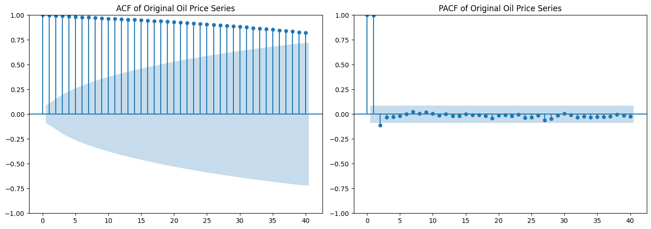Figure 3: ACF and PACF of the original series
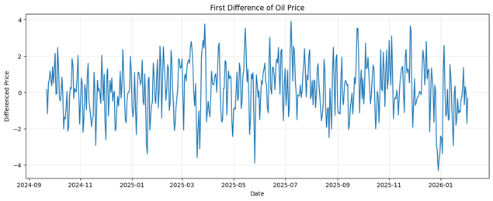Figure 4: First-differenced oil price series
ARIMA Model Development
The ARIMA model was built using the full grid search:
- $p=0$to $8$
- $d=0$to $2$
- $q=0$to $8$
Each model was fitted and ranked using the Akaike Information Criterion (AIC). In statsmodels, AIC is commonly used to compare fitted ARIMA models because it balances goodness of fit against model complexity; lower AIC suggests a better trade-off among the candidates being compared. Forecast intervals are also supported directly in the ARIMA workflow.
The best ARIMA model by AIC was:
- ARIMA (4, 2, 6)
- AIC: 1240.0649
- BIC: 1284.9693
- Log-likelihood: -609.0324
This result is interesting because the selected model used second differencing, even though the first-differenced series already passed the stationarity tests. This tells us something important: the model selection process preferred a more heavily differenced structure once the full lag terms were considered together. The fact that ARIMA (4,2,6) had the best AIC does not automatically mean it was the best forecasting model in practice.
- The full search found this order as the best in-sample statistical fit
- but forecast evaluation was still needed,
- and later results showed that the lowest AIC model was not the strongest overall forecasting method compared with Prophet and LSTM.
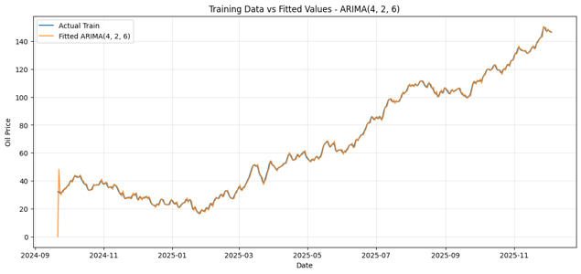Figure 5: Training vs fitted values for ARIMA (4,2,6)
ARIMA Residual Diagnostics
After fitting ARIMA (4,2,6), residual diagnostics were checked. This step is essential because a time series model should leave residuals that look close to white noise. If strong structure remains in the residuals, then the model has not fully explained the time dependence. The residual summary was:
- Count: 440
- Mean: 0.0984
- Standard deviation: 1.9635
- Minimum: -15.9000
- 25th percentile: -0.5690
- Median: 0.0579
- 75th percentile: 0.7189
- Maximum: 32.1000
The mean residual was close to zero, which is a positive sign. It suggests that the model was not systematically overpredicting or underpredicting across the training set. However, the large maximum and minimum values show that some errors were still large. This suggests that the model struggled with sharper price movements. The colab file also produced: a residual time plot, a residual histogram, a Q-Q plot, a residual ACF, and a Ljung–Box test.
These checks are important because they look at different sides of model adequacy. Residual ACF and Ljung–Box are especially useful for testing whether autocorrelation is still left in the errors.
Even when the residual mean is small, the model may still miss important features such as changing variance, tail behaviour, or sudden movements. For oil prices, that is not surprising. Oil markets can react sharply to news, and a univariate ARIMA model only uses past values of the same series. It does not know anything about external shocks. That limitation helps explain why ARIMA was statistically reasonable but not the strongest forecasting model in the final comparison. Recent oil-price studies also stress that nonlinear effects and structural breaks can reduce the performance of purely linear time-series models.
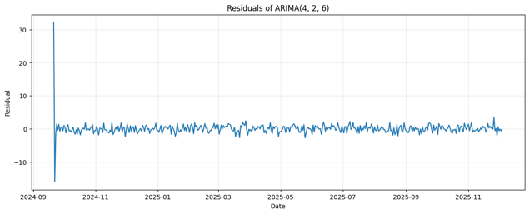 Figure 6: Residual time plot for ARIMA (4,2,6)
ARIMA Forecast Performance
The colab file used the last 60 days as a test set. This is important because it allows the model to be judged on unseen data rather than only on the training sample.
For the ARIMA test forecast, the results were:
- RMSE: 23.9591
- MAE: 19.0998
- MAPE: 14.9358%
These values show that the ARIMA forecast error on the 60-day hold-out period was large. This is a key result. Although ARIMA (4,2,6) had the best AIC, it did not produce the strongest medium-range forecast in the comparison.
The colab file also included a rolling one-step-ahead forecast for ARIMA, which gave:
- Rolling RMSE: 1.2002
- Rolling MAE: 0.9836
This difference is very useful for critical discussion. It suggests that ARIMA worked much better when it was allowed to update after each new real observation. In other words, ARIMA handled very short-horizon forecasting much better than a fixed multi-step forecast across the whole 60-day test period.
- ARIMA captured short-term local dependence well,
- but its direct multi-step forecast accumulated error over time,
- which is common when a model is recursively forecasting further into the future.
So, the ARIMA results were not simply “bad.” A better conclusion is that ARIMA was useful for near-term updating, but weaker for longer fixed horizon forecasting in this dataset.
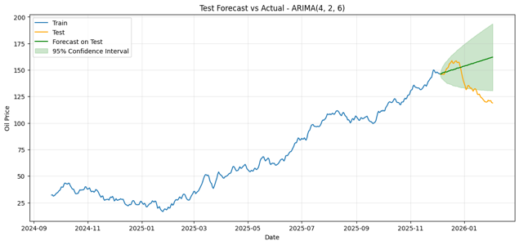Figure 7: ARIMA forecast on the test set with 95% confidence intervals
Prophet Model
Prophet was added as an alternative model because it handles time series through trend, changepoints, and seasonal components. The official Prophet documentation explains that it supports uncertainty intervals, changepoint flexibility, and diagnostics for forecast performance.
The best Prophet configuration was:
- Changepoint prior scale: 0.05
- Seasonality prior scale: 0.1
- Seasonality mode: multiplicative
Its test-set performance was:
- RMSE: 5.8943
- MAE: 5.0992
- MAPE: 3.8735%
- R²: 0.8132
This was a much stronger result than the ARIMA 60-day forecast. Prophet gave a far lower RMSE and MAE, which means its predictions stayed much closer to the real values over the test period.
Why did Prophet perform better here?
A likely reason is that the series had broader trend behaviour that Prophet was able to model more smoothly. Prophet is designed to fit changing trend patterns and can adapt using changepoints. That may have helped it follow the overall direction of the oil price series better than ARIMA’s recursive lag structure.
At the same time, Prophet is not a perfect model for oil prices. Commodity prices often have abrupt shocks, and Prophet can sometimes produce forecasts that are smoother than reality. So, its strong accuracy here does not mean that oil prices became easy to predict. Instead, it means that over this test period, the underlying pattern was captured well enough by a trend-focused model.
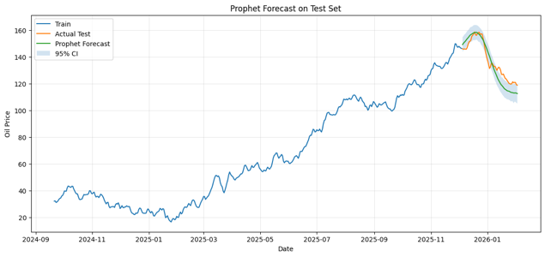 Figure 8: Prophet forecast on the test set with uncertainty interval

LSTM Model
LSTM was included as the deep learning model. LSTM networks are designed for sequential data and can learn nonlinear temporal patterns. Keras supports LSTM layers and sequence-based time-series input through sliding windows.
The best LSTM settings were:
- Sequence length: 7
- Units: 32
- Dropout: 0.0
- Batch size: 32
- Epochs: 30
Its final test performance was:
- RMSE: 6.1480
- MAE: 4.6246
- MAPE: 3.3778%
- R²: 0.7968
The tuning table earlier in the colab file showed a best search result around RMSE 5.9091, but the final fitted LSTM used for evaluation produced RMSE 6.1480. This is still a strong result and only slightly worse than Prophet in RMSE, while it produced a lower MAE and lower MAPE than Prophet.
This pattern is important. It suggests that the LSTM predictions may have had a few larger misses than Prophet, which increased RMSE slightly, but on average the absolute errors were smaller. That is why LSTM had better MAE and MAPE but slightly weaker RMSE. This is the kind of comparison that shows critical analysis rather than only reading one number from a table.
Why did LSTM perform well?
A likely reason is that oil prices contain nonlinear temporal structure, and LSTM is designed to learn such sequence behaviour. Recent work on crude-oil forecasting also reports that LSTM-based models can perform well when the data contain complex dependencies, although they can be sensitive to architecture and training settings.
However, there is also a limitation. The dataset here is not extremely large. Deep learning models often benefit from much longer time histories and richer inputs. So, while LSTM performed strongly, its success should be interpreted carefully. Good performance in this case does not prove that deep learning is always best; it shows that the short sliding-window sequence captured useful short-term behaviour in this specific dataset.
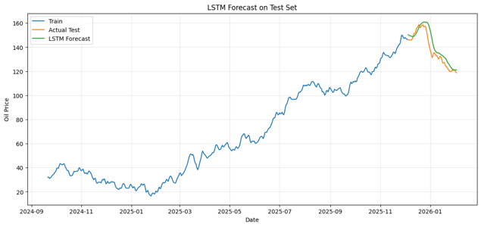Figure 16: LSTM forecast on the test set
Final Comparison of ARIMA, Prophet and LSTM
The final model comparison table from the colab file was:
Model | RMSE | MAE | MAPE | R²
Prophet | 5.89 | 5.09 | 3.87% | 0.81
LSTM | 6.14 | 4.62 | 3.37% | 0.79
ARIMA  (4,2,6) | 23.95 | 19.09 | 14.98% | —
Based on RMSE, the best model was Prophet.
Based on MAE and MAPE, LSTM was slightly stronger.
ARIMA was clearly weaker on the fixed 60-day forecast horizon.
- Prophet gave the best overall balance for this test period.
- LSTM was very competitive and had smaller average absolute error.
- ARIMA was weaker for long fixed-horizon forecasting, although its rolling one-step forecast was very strong.
Forecasts Compared with Real Data
The last 60 days acted as that real unseen period.
The comparison shows that:
- Prophet followed the real values closely and captured the broad direction well.
- LSTM also tracked the real series well and produced smaller average absolute errors.
- ARIMA did not match the real values as closely over the full test horizon.
This tells us something important about the nature of the series. The unseen part of the oil-price data appears to contain behaviour that was not explained fully by a linear ARIMA structure alone. Prophet handled the broader movement better, while LSTM captured short sequential patterns well. ARIMA was more sensitive to forecast error accumulation once it had to predict many steps ahead without correction.
This is a strong inference because it connects the result directly to the model design. The differences in error were not random. They reflect how each model learns from the data:
- ARIMA learns lagged linear dependence,
- Prophet learns trend and seasonal structure,
- LSTM learns nonlinear sequential patterns.
So, the real-data comparison supports the idea that this oil-price dataset contained more than just simple stationary lag behaviour.
Why the Results Look Like This?
First, the original series was non-stationary. That meant ARIMA had to rely on differencing before modelling the lag structure. Although ARIMA (4,2,6) gave the best AIC, second differencing may have made the model fit the training data well while also making the final multi-step forecast more sensitive to accumulated error.
Second, Prophet performed well because the series seemed to contain a smoother large-scale movement that Prophet could describe through trend and changepoint structure. The multiplicative seasonality setting may also have helped it adapt when the level of the series changed.
Third, LSTM performed well because the sequence length of 7 days allowed it to learn short-term temporal behaviour. Its lower MAE and MAPE suggest that it captured local patterns effectively, even though its RMSE was slightly above Prophet’s.
This explains why none of the models should be described as “perfect.” The more accurate conclusion is that some models were better suited to the structure seen in this dataset and forecast period.
Limitations of the Analysis
This work has several limitations.
The first limitation is that the analysis is mainly univariate. The models used past oil prices, but not outside predictors such as exchange rates, stock-market stress, OPEC decisions, production data, or macroeconomic indicators. Since oil prices are driven by many outside forces, this limits how much any pure price-only model can learn. Recent work continues to find value in hybrid and multivariable approaches for energy forecasting.
The second limitation is that the dataset contains 500 observations, which is acceptable for statistical models but still modest for deep learning. LSTM performed well here, but a longer dataset might lead to more stable deep learning results.
The third limitation is that the comparison used one main hold-out period of 60 days. This is useful, but it does not cover every possible market condition.
Future Improvements
There are several ways this analysis could be improved.
One improvement would be to add external predictors and test ARIMAX or other multivariable forecasting models. This could help the models respond to real market drivers rather than only past prices.
A second improvement would be to use rolling-origin cross-validation more extensively. Prophet’s diagnostics guidance recommends time-series cross-validation for more reliable forecast assessment across different cutoff points.
A third improvement would be to test hybrid models, for example combining volatility models with neural networks. Recent studies show that hybrid models can outperform single-model approaches in oil forecasting because they combine linear, nonlinear, and volatility information.
Conclusion
This report analysed daily oil prices from 2024 to 2026 using ARIMA, Prophet, and LSTM models. The early exploration, rolling statistics, and formal ADF and KPSS tests all showed that the original oil price series was non-stationary. Differencing was therefore necessary for ARIMA modelling.
The best ARIMA model by AIC was ARIMA (4,2,6) with AIC 1240.06, but its 60-day hold-out forecast was weaker than the alternative models, with RMSE 23.95, MAE 19.09, and MAPE 14.93%. However, ARIMA performed very well in rolling one-step forecasting, with RMSE 1.20, which shows that it was much stronger for short-horizon updating than for longer fixed-horizon forecasting.
Prophet achieved the best RMSE overall at 5.89, while LSTM was close behind with 6.14 and produced the lowest MAE and MAPE. This suggests that Prophet captured the broader movement of the series very effectively, while LSTM handled short-term sequence behaviour very well.
The most important conclusion is not just which model had the smallest error. It is that the oil-price series contained behaviour that could not be fully explained by one simple linear approach alone. The final comparison showed that model performance depended strongly on the structure of the series and on the forecast, horizon being used.
Reference List
Box, G.E.P., Jenkins, G.M., Reinsel, G.C. and Ljung, G.M., 2015. Time Series Analysis: Forecasting and Control. 5th ed. Wiley.
Keras, 2026. LSTM layer and Timeseries data loading documentation.
Prophet, 2026. Uncertainty Intervals and Diagnostics documentation.
Choudhary, J. et al., 2025. Price Forecasting of Crude oil using Hybird Machine Learning Models.
Osaro, E., 2025. Crude oil price prediction using machine learning LSTM.
statsmodels, 2026. Forecasting in statsmodels, ADF test, and KPSS test documentation.

